EGR: 226 Microcontroller Programming and Applications

Winter 2021

Instructor Prof. Trevor Ekin

**Lab 10: Interfacing the MSP432 with a Temperature Sensor, Converting the Analog**

**Voltage to Digital Samples, and Displaying on the LCD**

Gabriel Gasbarre

April 1st, 2021

Contents

1. Objectives 3

2. Equipment 3

3. Introduction 4

Pre-Lab 4

3.2 Part 2 - Converting an analog voltage from a temperature sensor and displaying the current temperature on an LCD 5

3.3 Part 3 - Displaying temperature on the LCD 5

4. Procedure: 5

4.1: Part 1 - Configuring the ADC and testing the input 5

4.2: Part 2- Converting an analog voltage from a temperature sensor and displaying the current temperature on an LCD 6

4.3 Part 3 - Displaying temperature on the LCD 7

5. Results: 8

5.1 Part 1 Results 8

5.2: Part 2 Results 8

5.3: Part 3 Results 8

6. Conclusions. 8

1. Objectives

* To interface an analog sensor with the MSP432 using the Analog to Digital Converter (ADC) peripheral to convert a voltage proportional to temperature into digital samples
* To learn how to program with interrupts for efficient handling of ADC samples
* To use the LCD interface from lab 6 to display temperature

1. Equipment

|  |  |  |
| --- | --- | --- |
| **Part** | **Description** | **Model** |
| CCS (Code Composer Studio) | Integrated development environment to develop applications for Texas Instruments embedded processors. | 10.0.00010 |
| MSP432 | Mixed-signal microcontroller family from Texas Instruments. | MSP432P401x |
| EGR:226 Lab 6 Exercise | Interfacing a keypad with the MSP432 | N/A |
| Photodiode Infrared LED’s | electronic components that emit and receive infrared light | N/A |
| LCD Screen | EGR 226 Lab Kit LCD display with HD44780 controller | HD44780 |
| MOSFET Transistor | Insulated-gate field-effect transistor | 2N7000 |
| Temperature Sensor | 3-pin variable voltage temperature sensor | TMP36 |

1. Introduction

## 3.1 Pre-Lab

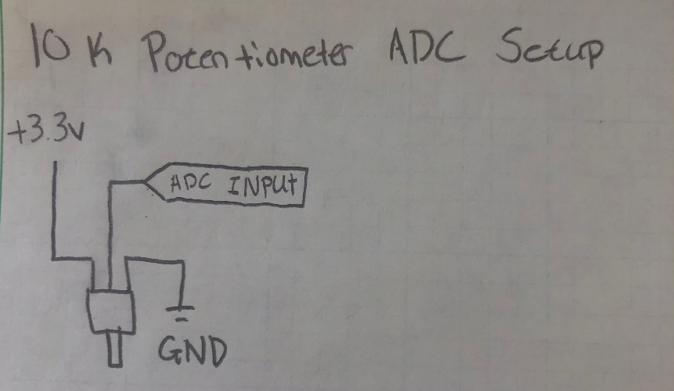

Example ADC Code from Dr. Kandalaft:

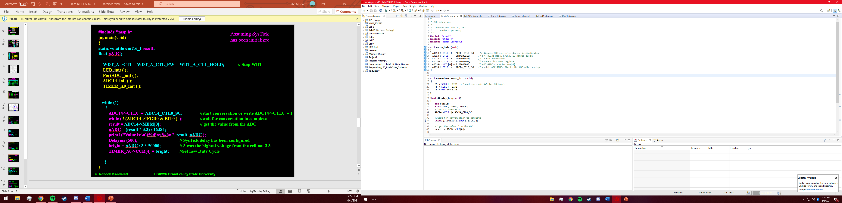

## 

3.1: Part 1- Configuring the ADC and testing the input For part one, students are to use the imported example code that was described in lecture combined with their potentiometer to the 3.3V power supply and ground so that it will generate a test voltage when the knob is turned. This voltage should be between 0 and 3.3 volts when received by the ADC and converted to an input voltage.

## 3.2 Part 2 - Converting an analog voltage from a temperature sensor and displaying the current temperature on an LCD

Using the circuit designed in part one, students should use the TMP36 sensor that delivers an appropriate signal to an input pin on the MSP432 MCU. Students should modify their code from part one so that it is now connected to the temperature sensor output voltage. This output voltage should then be converted to a temperature reading in Celsius and in Fahrenheit.

## 3.3 Part 3 - Displaying temperature on the LCD

For part 3, students should integrate their code from lab 6 to show the message “Current Temp is:” on the first line of the LCD display. On the second line, the LCD should display the current temperature reading to the nearest tenth of a degree, centered. Students must also use the degree symbol.

# 4. Procedure:

4.1: Part 1 - Configuring the ADC and testing the input

To receive the correct ADC input voltages through the potentiometer, students must first create the circuit as described in the pre-lab assignment. Using the code provided in the pre-lab, this ADC value is then received and stored in mem[0], which must be converted to voltage using (mem[0] * 3.3) / 16384. The value of 16384 is because as seen in the ADC initialization from the pre-lab, 14-bit resolution was selected. This voltage can now be stored and printed to the console or used for further calculations.

4.2: Part 2- Converting an analog voltage from a temperature sensor and displaying the current temperature on an LCD

For part 2, students are to replace their potentiometer with the TMP36 temperature sensor (ensuring the pin connections are correct.) This temperature sensor delivers a voltage value proportional to the temperature, which must be measured and converted to Celsius / Fahrenheit. To do so, the conversion used is as follows:

Temp in C = [(Vout / 1000) – 500 ] / 10

This temperature value can then be saved, converted to Fahrenheit, and / or printed to the console. An example of this code that prints the F / C temperature values to the console is provided below.

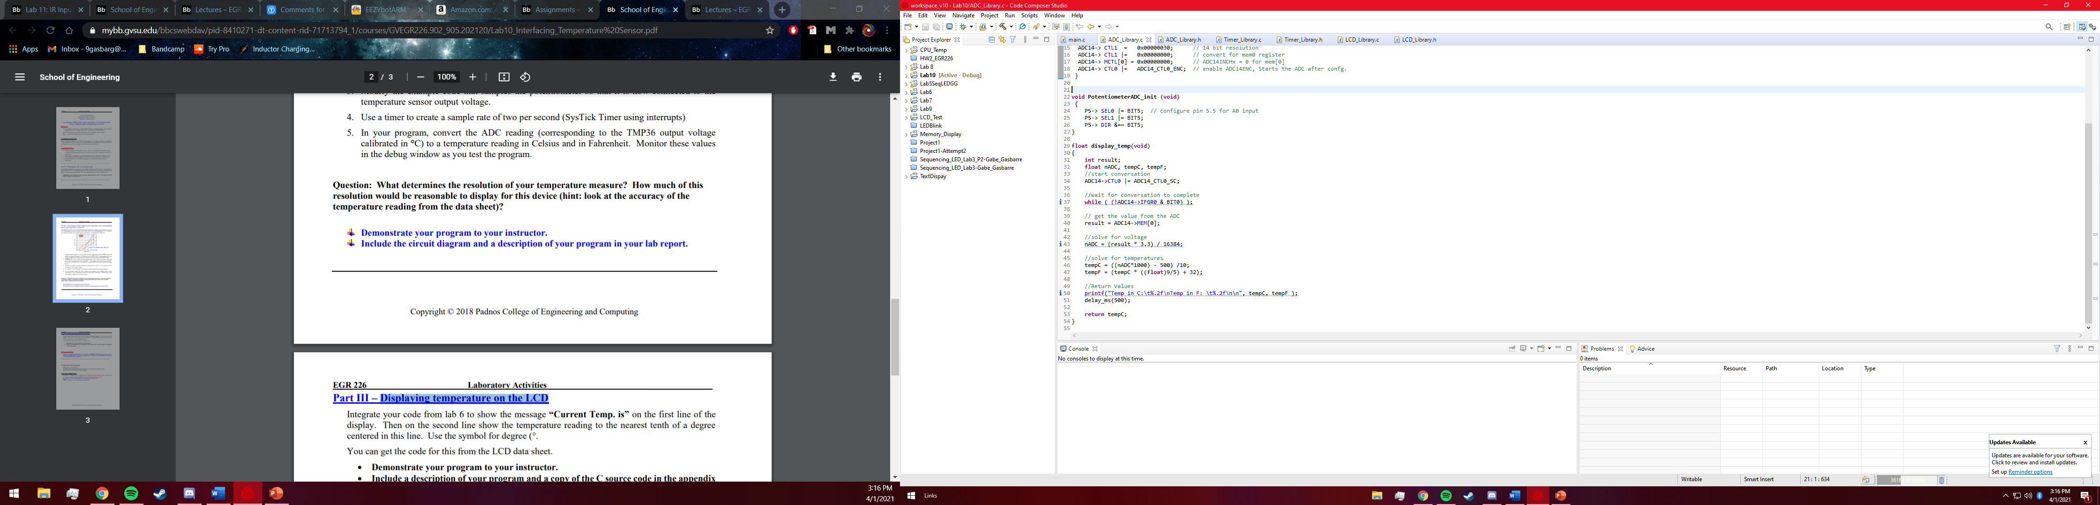

## 4.3 Part 3 - Displaying temperature on the LCD

For part 3, students are to integrate their LCD screen to display the temperature values calculated in part 2. To do so, the LCD library from lab 6 was used. Because a function to print strings was already created in this library, the temperature values along with the display text must be converted into a string using the “sprintf” function. Printing the degree symbol is made possible by defining a character with the data value of the symbol from the HD44780 data sheet, and then including this value in the string. Included below is the code that receives temperature values and sends them, along with the display text, to the LCD.

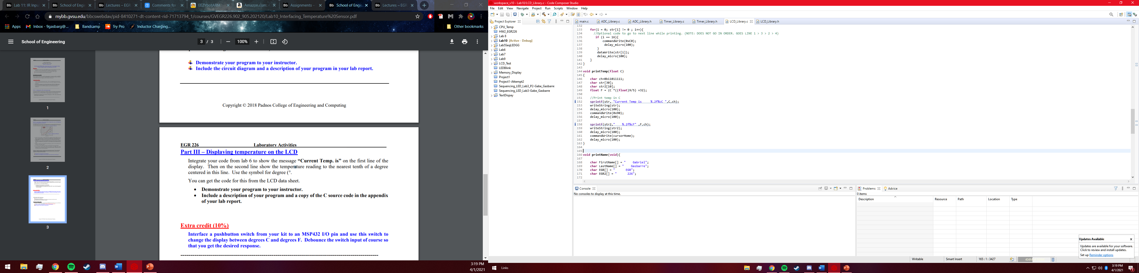

# Results:

* 1. Part 1 Results

Part one was probably the most difficult part of this lab as it was, like most labs, the initial foundation that the remaining parts would be built upon. Storing and retrieving the ADC values was slightly difficult, but it turned out to be that the potentiometer was simply connected to the wrong pin. After sorting out this issue the values received seemed to be perfectly accurate and fell within the desired voltage range.

5.2: Part 2 Results

Part 2 of the lab was probably the easiest, as all that was to be done was to swap out the potentiometer with the temperature sensor, and then convert the voltage received to degrees Celsius. The only real issue with this part was the mathematical conversion from degrees C to F, as a floating point calculation was required. After this calculation error was solved, the correct Celsius and Fahrenheit values were easily printed to the console window.

## 5.3: Part 3 Results

Part 3 of the lab was certainly the most satisfying as there is always some appreciation in creating a “final” product, one that works independently from needing to be plugged into the computer. It was also quite enjoyable to have used a personally created LCD library rather than using one provided. This final part also caused very little problems as the LCD is very familiar with all the time spent working with it.

# Conclusions.

This was ultimately a very successful lab, though being one of the simpler ones. This was certainly a wonderful introduction to receiving ADC values and converting them, and will hopefully make the following labs, along with the final project, much easier to complete as the ADC library created in this lab has some wonderful reverences.